Conceptual model of
Fixed assets management system

Version 0.0

Students:
19522467 – Le Thanh Tuan
19520358 – Pham Hieu Vy
19522455- Phung Thanh Tu
Document change record sheet

Date | Version | Description | Authors
25/10/2021 | 0.0 | Initial document. | Phung Thanh Tu, Le Thanh Tuan and Pham Hieu Vy co-operated.
11/12/2021 | 0.0 | Login sequence diagram | Phung Thanh Tu

Table of contents

1. Class diagram (analysis/conceptual level) 3
1.1 Class diagram (analysis level) 3
1.2 List of classes and relationships in Database Module 3
1.3 List of classes and relationships in UI Module and Login Module 4
2. Cohesion and coupling 4
3. State machine diagram (2-3 diagrams) 4

Class diagram (analysis/conceptual level)

Class diagram (analysis level)
Due to the high complexity of this diagram, I don’t show the analysis level of the class diagram. Updates will be made later.
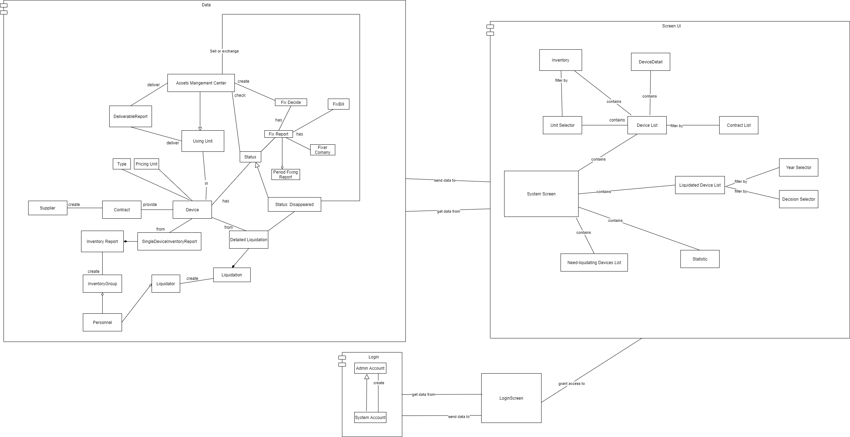

List of classes and relationships in Database Module

.No | Class/Relationship | Type | Note
1 | Assets Management Center/Generalization |  | Using Unit
2 | Assets Management Center/Association
3 | Using Unit/Association
4 | Deliverable Report/Association
5 | Period Fixing Report/Aggregation |  | Fix Report
6 | Fix Report/Association
7 | Fix Decision/Association
8 | Fix Bill/Association
9 | Fixer Company/Association
10 | Status/Generalization |  | Status: Disappeared
11 | Status/Association
12 | Status: Disappeared/Association
13 | Device/Association
14 | Type/Association
15 | Pricing Unit/Association
16 | Contract/Association
17 | Supplier/Association
18 | Single Device Inventory Report/Association
19 | Single Device Inventory Report/Composition |  | Inventory Report
20 | Inventory Report/Association
21 | Inventory Group/Association
22 | Personnel/Aggregation
23 | Liquidator/Association
24 | Liquidation/Composition |  | Detailed Liquidation
25 | Detailed Liquidation/Association

List of classes and relationships in UI Module and Login Module

.No | Class/Relationship | Type | Note
1 | Login Screen/Generalization
2 | Screen/Association
3 | Device List/Association
4 | Contract List/Association
5 | Device Detail/Association
6 | Inventory/Association
7 | Unit Selector/Association
8 | Liquidated Device List/Association
9 | Year Selector/Association
10 | Decision Selector/Association
11 | Statistic/Association
12 | Need-liquidating Devices List/Association

Cohesion and coupling
- Coupling in this diagram: Data Coupling because the three modules communicate with each other by transferring data only.
- Cohesion in this diagram: Sequential Cohesion because data in database module flow between elements.

State machine diagram (2-3 diagrams)
State machine diagram haven’t been developed yet

Sequence diagram.

Login sequence diagram
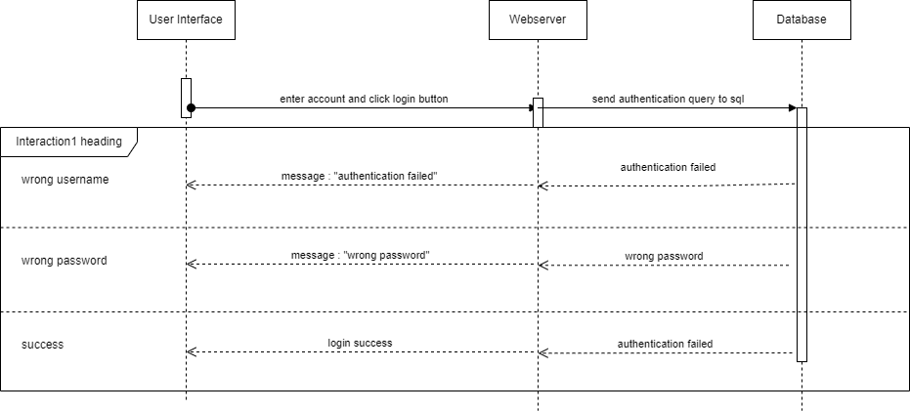

Add contract sequence diagram

Show Device List sequence diagram

